**NETWORKING & SYSTEM ADMINISTRATION LAB**

|  |
| --- |
| **Name: SREELEKSHMI ANILKUMAR**  **Roll No:42**  **Batch:S2 RMCA**  **Date:25/04/22** |

**Experiment No.: 7**

**Aim**

Familiarization of Linux Commands.

# Procedure and Output Screenshot

**1)sudo useradd** useradd is a command in Linux that is used to add user accounts to your system.

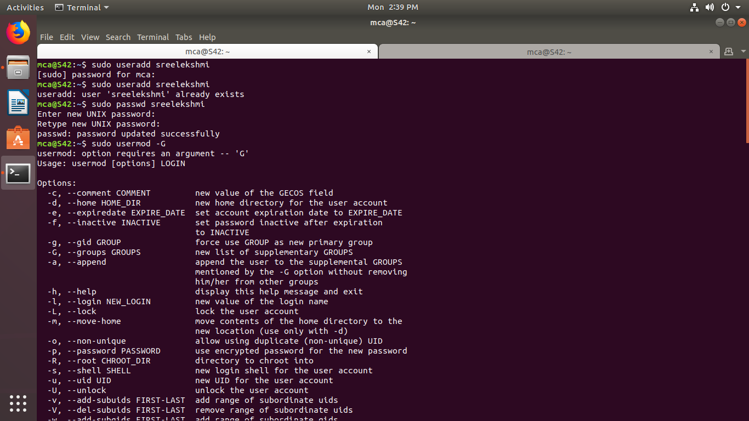

**2)sudopasswd** *passwd* command in Linux is used to change the user account passwords.



# 3)sudo groupadd

[Groups i](https://www.geeksforgeeks.org/groups-in-linux-system-administration/)n Linux refer to the user groups.***groupadd*** command is used to create a new user group.

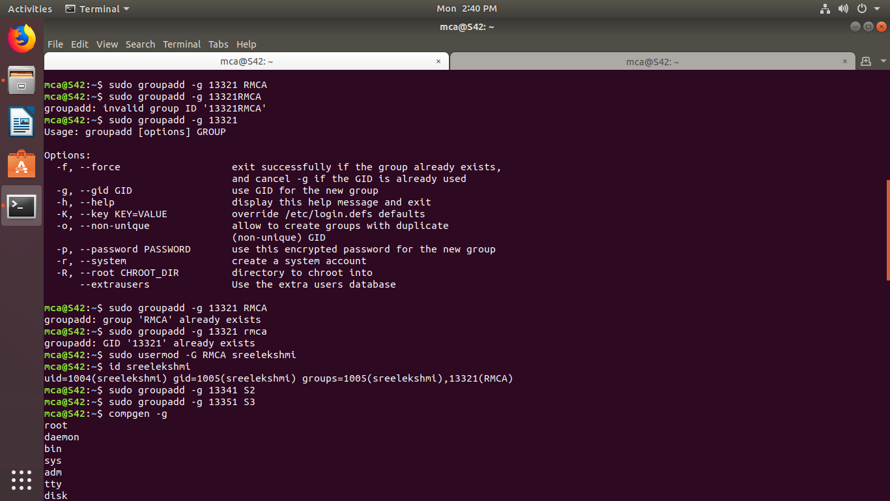

# 4)sudo usermode

Sudo means: Run this command as root. This is required for usermod since usually only root can modify which groups a user belongs to

Usermod is a command that modifies the system configuration for a specific user



# 5)compgen –g

compgen is a bash built-in command which is used to list all the commands that could be executed in the Linux system



**6)sudo usermod**

**-G** = To add a supplementary groups.

**7)sudo userdel**

The userdel command removes the user account identified by the login parameter.

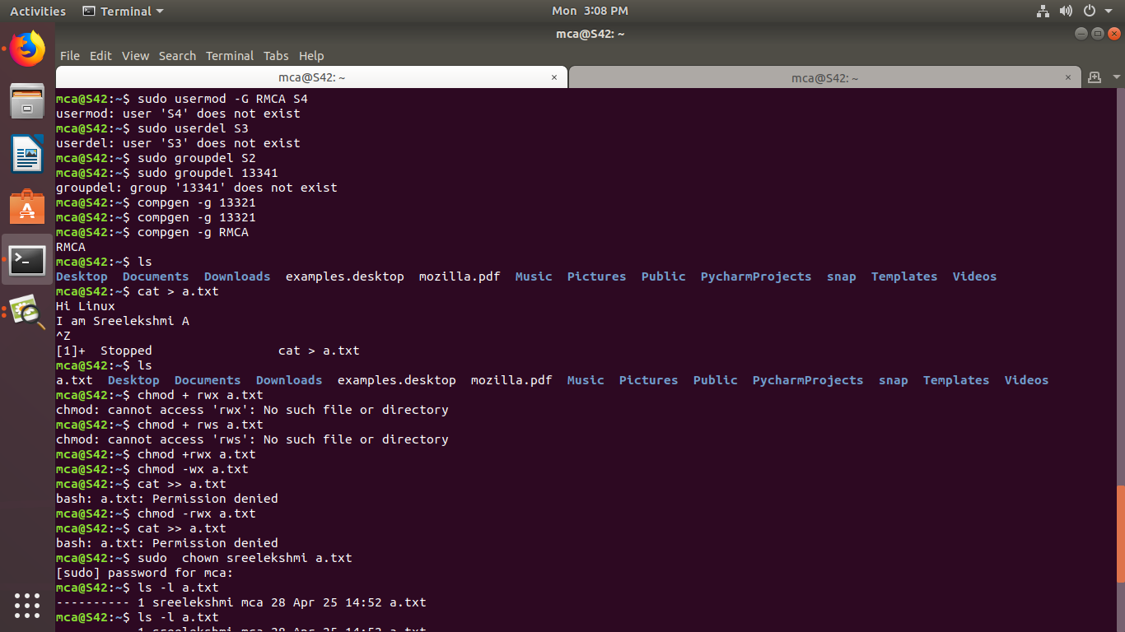

# 8)chmod

the chmod command sets the [permissions](https://www.computerhope.com/jargon/p/permissi.htm) of [files](https://www.computerhope.com/jargon/f/file.htm) or [directories.](https://www.computerhope.com/jargon/d/director.htm)

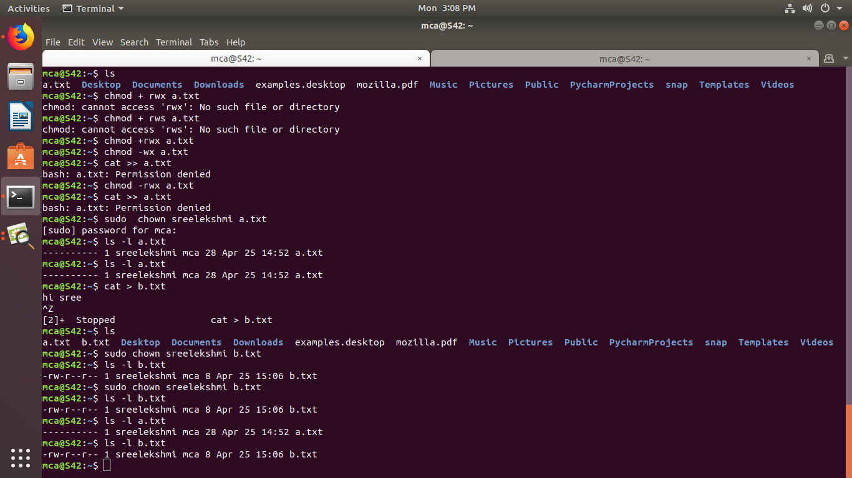

**9)sudo chown** chown command is used to change the file Owner or group.

